Magic Invitational Report: Jon Finkel
Jon Finkel
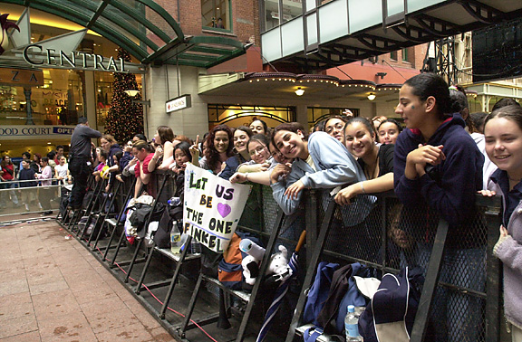
Last year I flew across the globe to play some Magic in Sydney, Australia. As per the norm, I had no preparation, but I didn't really care that much and I was hoping it wouldn't matter. I guess I got lucky. I met Chris Pikula at Newark airport and had hours of whining and complaining to look forward to. Luckily, it was funny whining and complaining, and, even more luckily, the Great One himself, Bob Maher Jr. joined us in Los Angeles. Now I won't get into the details of the flight across the endless ocean, but suffice to say that at some point in this trip I watched both Coyote Ugly and The Perfect Storm. And those were the "good" movies. Let me stop for a second and reflect on Coyote Ugly. Never before have I seen a movie in which cause, effect, and reality were so loosely connected. Godzilla had better writers and the political scenes in Dungeons & Dragons (On this day, I declare you all equal...) had more heft and reason to them. I cannot think of a single reason why anyone should ever see this movie.
Except maybe for the fact that it isn't The Perfect Storm. Let me tell you right now, that the word "perfect" does not belong anywhere in the title of this movie except maybe as some sort of twisted irony. There I was, bored out of my mind on a transpacific flight, having watched 90 minutes of a movie about to reach its climax and I stop watching it. That's right, I watched one and a half-hours in the lives of heroic fishermen from New England, and I could not bring myself to care what actually happened to them. Compared to watching The Perfect Storm, staring blankly at the seat in front of me was like blissful heaven. But I digress. You came here to read about Magic. I'm probably not going to talk about it much, but I figure I should at least try to stay on topic.
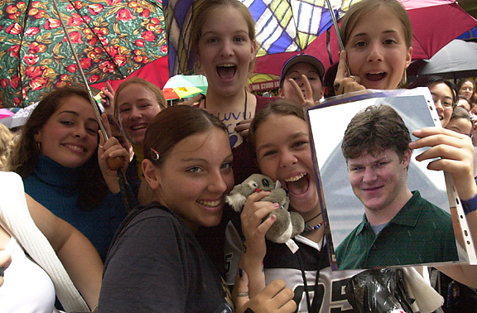
Ben Rubin's biggest fans
So I finally get into sunny Sydney - wait, make that rainy, dreary, dismal Sydney. Apparently my vacation from New York autumn into semi-tropical Australian spring coincided with the only week of constant rain in the entire history of Sydney. So I did what any true American gamer would: I stayed inside the whole time. In actuality that's a lie, but I could have, and in fact strongly considered it - after all, we were in a veritable entertainment city: casino, dance club, countless bars and restaurants, malls, and of course, the prestigious Magic Invitational. Also there were girls in prom dresses everywhere, everyday. I still can't explain it or understand it any way. Maybe they'd all heard that Gary Wise was going to be there and they wanted a glimpse - after all, hordes of adoring teenage girls were spotted sporting pictures of Ben Rubin. What can I say, they're sexy men.
Somewhere along the way on this trip, I managed to do lots and lots of fun and interesting things. Some of them I'm not at liberty to talk about here, while some of them, on the other hand, I can talk about but may just as easily forget or lie about. I haven't really decided yet. Or, more accurately, the voices in my head haven't. Onward to the tournament. Now you're going to forgive me here because I'm going to talk about the formats in order but not the matches within them or necessarily all of my opponents. Pretty much just what my memory will recollect as I'm typing.
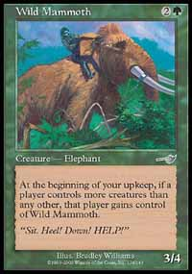
It was a little cheaper at the Invitational
Duplicate Limited was the first event. This was very good for me because I had a huge advantage in this event - everyone else was as unprepared as I was. So there I am looking at all the overcosted cards and salivating over Mana Drain, Forbid, and Exclude as I slowly realize that blue and white are, in actuality, awful. Then in one of those epiphinaical (Is that a word? There should be an adjective form of epiphany so I'll use that and maybe some day an etymologist will put me in the dictionary) moments that makes one accept God or become a devout Branch Davidian, I had an image of Dave Price appear before me. "And on the fourth day, he lookethed over the land, and sayeth 'For he that beateth down shall have my power before him, and he shall raiseth his hand, and his enemies shall be smitten before him." So with a quick nod to the King of Beatdown, I whipped out the friendly Wild Mammoth and put together a red-green deck of savage aggression the likes of which the world had never seen before.
Now I'm sure I played Ryan Fuller in this format. For some reason, Ryan brings out the ounce of personality I have when I play him and I can't help but make a friendly quip or two - Ryan also takes it really well especially since usually I'm not even in the same ballpark of funny. Luckily for me, as Wizard's poster boy, they decided to cut the Worlds Team show on ESPN to make me look as witty as possible with perhaps the only two decent one-liners I have ever told. Anyway, in an eerily similar moment to Worlds, Ryan was getting all jiggy on his side of the table with his Aladdin/Thran Forge combo, prompting him to comment on my deep introspection - "Awfully quiet over there, aren't we Jon?" "I'm just thinking about how I'm going to kill you" I said as I busted out Subterranean Spirit, who had issues with Ryan's entire team, and soon had him down and out, after which he managed to squeak out "uncle". I don't really remember the other games in this match, but I do remember spending a lot of time with Ryan and Jamie outside of the Invitational - cool, fun people who like to have a good time.
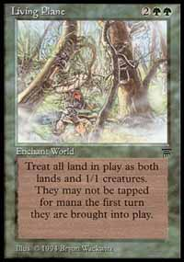
I also played Superman in Duplicate Limited. For those of you who aren't in the know, that's Ben Rubin, so named for his valiant quest to fight for "Truth, Justice, and the American Way" and his amazing ability to keep it up all night long - not that I'd know anything about that. We split the first two games, leaving the third game to be an epic clash of the titans. I decided to lock Ben on about the 4th turn with Groundskeeper, Living Plane, and Goblin Bombardment. You do the math.
I also played somebody else in Duplicate Limited. I don't remember who it was. It might have been Chris or Kai. It was Chris I played. I remember very little about this match and I don't have the inclination to make up any decent lies.
The next three rounds were Bring Your Own Block. While considering what deck to play in this format I remembered some words William Shakespeare blatantly plagiarized from me in Hamlet, "Above all else, to thine own self be true." So I busted out my turbo-saproling deck - I'd show all those netdeck-using sissies what a real rogue deck designer could do. Unfortunately it wasn't legal in the format. Plus I'm not a pathetic, sniveling loser even if I do have a confused sense of gender identity and am a self-destructive manic-depressant. Anyway, after all of this soul searching and self hate, I threw together a pile of blue cards which unfortunately looked a lot like what Randy Buehler played at Worlds one year. I can just see him right now floating around the office plotting the demise of a young man of House Atreides. And, yes, I spent minutes on the syntax of that sentence because I can't remember the guy's name from Dune. Sue me. Now I know for a fact that I lost to Trevor Blackwell in this format. He had this Stone Rain card that he just refused to stop casting. After this humiliating defeat, I resolved to strengthen my Shaolin Powers - never again would I allow myself to lose to a worthy opponent, and with the exception of the aforementioned King of Beatdown I managed only to lose to people without a chance of winning. Perhaps next time I will also meditate for strength against those who are unworthy as well.
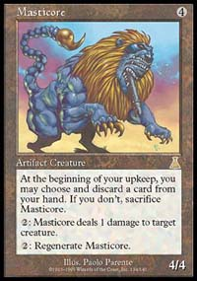
Luckily for me, next I played the worthiest of adversaries, the Great One himself, Robert Patrick Maher Jr. Now for those of you who are sticklers for accuracy out there, it is altogether possible that I played Trevor after I played Bob, thereby exposing me as a liar, but I swear that the rest of the report is true - especially the part with the rabbits. I also may have actually played Bob after Trevor. Anyway, TGO was playing Counterpost, which everyone knows that only an utter idiot would play in a major tournament like the Invitational or U.S. Nationals. Game one, a pair of loyal Masticores trampled Bob into oblivion in a beatings the likes of which I hadn't scene since I mauled Zvi last year. Also I got savagely lucky. Game 2, I ground right through Bob's skull. Basically 4 Grindstones and 4 Thran Foundries just aren't fair.
So after TGO I moved onto ZVI, an equally worthy adversary. Fortunately the deck selection portion of his brain wasn't functioning too well as he decided to go with Tradewind-Awakening. I'm sure Zvi realizes this now, but "T and A" wasn't even the third-best deck in Rath Cycle, not to mention Bring your Own Block. Luckily for Zvi, Kai hadn't won a match up to this point and had practically locked up last place, so even if Zvi were to choose Long's deck AND monoblue in Type 1, he seemed pretty safe. After all, Kai was well on his way to a performance worthy of a Canadian.
Now the third format was Solomon draft. I went 1-2 in this format but that's okay because I played Senor Price, who is practically an auto loss for me. In fact, I can count the number of times I've beaten him in tournaments on the fingers of a bloody stump where a hand used to be. Maybe next year. Now in all three of my matches I tried to outthink Rosewater, and I failed miserably in two of the three, hence the reason behind my reception of savage beatings. If anyone out there ever makes the Invitational, don't try to understand the convoluted mind of Mr. Rosewater, it's just too hard. But he looks awfully cute in a pair of Daisy Dukes.
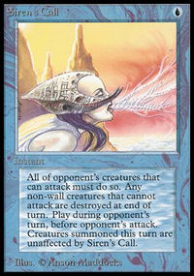
Day 3 I got very lucky. You see, it seems that while I decided to play Type 1 all day, everyone else only wanted to play it for three rounds. Now obviously this seems like a poor choice on most of their parts, but there's no accounting for taste - just look at NASCAR. Highlights from my three rounds with the Wand of Wonder include killing no less than ten creatures with Siren's Call. And locking people on two separate occasions with a second-turn Time Elemental combined with a Strip Mine. Well, at least I had fun. The biggest thing I learned was that all of those utterly horrible cards that Zak used actually work pretty well together, and seven cards and a Type 1 deck will beat out six cards and a Block Constructed deck any day of the week.
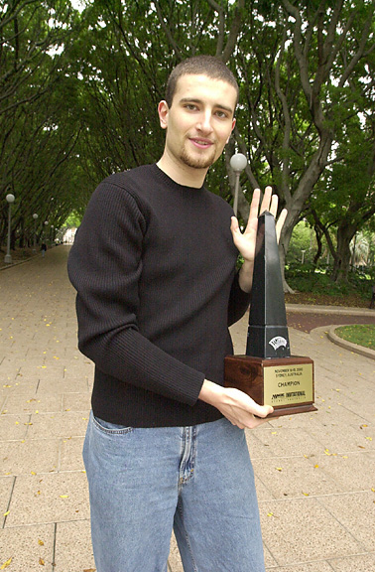
Then came Type 1 for real. Now I love Type 1, but not as much as Darwin Kastle. In fact, at one point he pondered the exact manner of the meteoric rise his pro career would take if every tournament was Type 1. And perhaps he would never lose - he gave me a beating the likes of which only the Clippers see on a regular basis. Luckily for the rest of us, there were also Limited formats in the Invitational. I also played Alex Shvartsman in Type 1, but I don't remember much in the way of the games. In fact, I'm not even 100% sure I know who won, although I think it was me. In the last round of the tournament, I played the inimitable Mike Long. Mike and I actually had some pretty good times during the course of the trip to Sydney, which is why I felt so especially bad for ending the tournament with such an utter and crushing victory over him. I'm sure there are certain pieces of his anatomy still tender from the beating I gave him in one turn. If you are so inclined, you can read about it here. If, on the other hand, you're lazy like me, let's just say the highlights included destroying all permanents in play, then playing over a half dozen cards out of my graveyard, followed by a Mind Twist for 7 and a Stroke of Genius for 5. I think the Baron almost had a heart attack as he watched.
In the finals I played Benjamin Rubin of San Francisco, California. Now for those of you who don't remember, I got humiliated in the finals last year by Pikula, and I was determined not to let it happen again. Luckily, I had two almost auto wins in the Auction of Champions and Bring your Own Block. And I wasn't disappointed. Between those two and the friendly, neighborhood CoP: Red I elected to play main deck, I was able to bring out the broom for Ben. After all, he is Mr. Second Place, and I pity the fool who actually loses to him in the finals of a major event.

